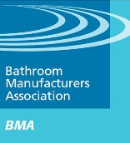
412 | 06 Nov 2012
Press Statement
Yvonne Orgill, Chief Executive of the Bathroom Manufacturers Association

World Toilet Day – what can you do?
Although it’s unthinkable for those of us living in the more wealthy parts of the world, it is a harsh reality that one in three people on our tiny planet don’t have access to either a toilet or drinkable water.
Poor sanitation and lack of access to clean water is one of the world’s key issues.
The humble toilet can be a stepping stone to a healthier life, greater dignity, freedom, equality between women, men, girls and boys, and a major catalyst to the development of communities and countries.
So what can you do about it? You can play your part and the very least you can do is support World Toilet Day www.worldtoiletday.org
It’s now less than a fortnight away and on 19 November – the same date every year – World Toilet Day will endeavour to raise awareness of sanitation issues and highlight the plight of those 1 in 3 people – that’s 2.5 billion - who don't have access to proper sanitation.
The Bathroom Manufacturers Association supports the aims and ideals of World Toilet Day. It its own way the BMA promotes the urgent need for us all, no matter where in the world we live, to use water efficiently, without waste, and as wisely as possible. We need to ensure that this precious resource is treated with the respect it deserves for the benefit of our future generations.
Can you imagine not having a toilet? Can you imagine not having privacy when you need it the most? Can you imagine having no access to clean water? Probably not. So what can you do about it?

The BMA, based at Keele’s Innovation Centre, is the trade association for bathroom manufacturers operating in the UK. It is the principal ‘Voice of the Bathroom Industry’ and acts as an information highway between industry, government and the consumer on issues that affect the bathroom business.
The BMA represents, through its technical, marketing and management committees, the interests of 55 major bathroom manufacturing groups and service providers with over 80 well-known brands in the market place. The manufacturing base directly employs 10,000+ people across 79 sites around the UK.

ENDS
A variety of digital images are available upon request. However, the BMA is a non-profit organisation and unable to pay for images to be reproduced. The aim of the information generated by the BMA is to educate, inform and improve the industry as a whole.

Further Information about the BMA
For further information email info@bathroom-association.org.uk
or telephone 01782 631619 or visit www.bathroom-association.org

The BMA | NOTES for editors

What is the BMA? | The BMA is the trade association for bathroom manufacturers operating in the UK. It is the principal ‘Voice of the Bathroom Industry’ and acts as an information highway between industry, government and the consumer on issues that affect the bathroom business.
The BMA represents, through its technical, marketing and management committees, the interests of 55 major bathroom manufacturing groups and service providers with over 80 well-known brands in the market place. The manufacturing base directly employs 10,000+ people across 79 sites around the UK.

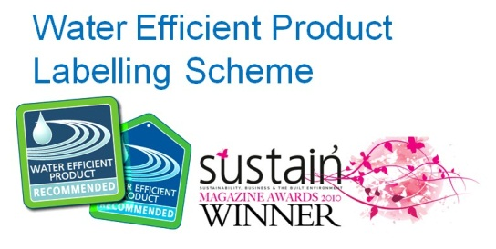
Main website at www.bathroom-association.org
Microsites at
www.bathroom-academy.co.uk
www.water-hog.co.uk
www.water-label.eu
www.thewatercalculator.org.uk/

News Blog http://bmanewsblog.blogspot.com/
Twitter http://twitter.com/BMAbathrooms
LinkedIN www.linkedin.com/pub/bathroom-manufacturers-association/26/508/a9b
Facebook www.facebook.com/pages/Bathroom-Manufacturers-Association/165891423422538
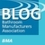

Chief Executive | Yvonne Orgill
Technical Director | Christian Taylor-Hamlin
Bathroom Manufacturers Association,
Innovation Centre 1,
Keele Science and Business Park
Newcastle-under-Lyme,
ST5 5NB

Telephone 01782 631619
Fax 01782 630155
email: info@bathroom-association.org.uk

